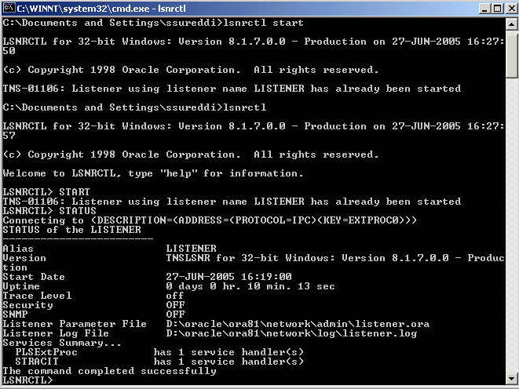

# LISTENER.ORA Network Configuration File: D:\oracle\ora81\network\admin\listener.ora
# Generated by Oracle configuration tools.

LISTENER =
(DESCRIPTION_LIST =
(DESCRIPTION =
(ADDRESS_LIST =
(ADDRESS = (PROTOCOL = IPC)(KEY = EXTPROC0))
)
(ADDRESS_LIST =
(ADDRESS = (PROTOCOL = TCP)(HOST = dev1)(PORT = 1521))
)
)
(DESCRIPTION =
(PROTOCOL_STACK =
(PRESENTATION = GIOP)
(SESSION = RAW)
)
(ADDRESS = (PROTOCOL = TCP)(HOST = dev1)(PORT = 2481))
)
)

SID_LIST_LISTENER =
(SID_LIST =
(SID_DESC =
(SID_NAME = PLSExtProc)
(ORACLE_HOME = D:\oracle\ora81)
(PROGRAM = extproc)
)
(SID_DESC =
(GLOBAL_DBNAME = STRACIT)
(ORACLE_HOME = D:\oracle\ora81)
(SID_NAME = STRACIT)
)
)

# TNSNAMES.ORA Network Configuration File: D:\oracle\ora81\network\admin\tnsnames.ora
# Generated by Oracle configuration tools.

EXTPROC_CONNECTION_DATA.PICS-TDH.COM =
(DESCRIPTION =
(ADDRESS_LIST =
(ADDRESS = (PROTOCOL = IPC)(KEY = EXTPROC0))
)
(CONNECT_DATA =
(SID = PLSExtProc)
(PRESENTATION = RO)
)
)

INST1_HTTP.PICS-TDH.COM =
(DESCRIPTION =
(ADDRESS_LIST =
(ADDRESS = (PROTOCOL = TCP)(HOST = dev1)(PORT = 1521))
)
(CONNECT_DATA =
(SERVER = SHARED)
(SERVICE_NAME = STRACIT)
(PRESENTATION = http://admin)
)
)

STRACIT.PICS-TDH.COM =
(DESCRIPTION =
(ADDRESS_LIST =
(ADDRESS = (PROTOCOL = TCP)(HOST = dev1)(PORT = 1521))
)
(CONNECT_DATA =
(SERVICE_NAME = STRACIT)
)
)

STRACIT =
(DESCRIPTION =
(ADDRESS_LIST =
(ADDRESS = (PROTOCOL = TCP)(HOST = dev1)(PORT = 1521))
)
(CONNECT_DATA =
(SERVICE_NAME = STRACIT)
)
)

# SQLNET.ORA Network Configuration File: D:\oracle\ora81\network\admin\sqlnet.ora
# Generated by Oracle configuration tools.

NAMES.DEFAULT_DOMAIN = PICS-TDH.COM

SQLNET.AUTHENTICATION_SERVICES= (NTS)

NAMES.DIRECTORY_PATH= (TNSNAMES, ONAMES, HOSTNAME)

WHEN I CHANGED TNSNAMES.ORA TO LIKE THIS

# TNSNAMES.ORA Network Configuration File: D:\oracle\ora81\network\admin\tnsnames.ora
# Generated by Oracle configuration tools.

EXTPROC_CONNECTION_DATA.PICS-TDH.COM =
(DESCRIPTION =
(ADDRESS_LIST =
(ADDRESS = (PROTOCOL = IPC)(KEY = EXTPROC0))
)
(CONNECT_DATA =
(SID = PLSExtProc)
(PRESENTATION = RO)
)
)

INST1_HTTP.PICS-TDH.COM =
(DESCRIPTION =
(ADDRESS_LIST =
(ADDRESS = (PROTOCOL = TCP)(HOST = dev1)(PORT = 1521))
)
(CONNECT_DATA =
(SERVER = SHARED)
(SERVICE_NAME = STRACIT)
(PRESENTATION = http://admin)
)
)

STRACIT =
(DESCRIPTION =
(ADDRESS_LIST =
(ADDRESS = (PROTOCOL = TCP)(HOST = dev1)(PORT = 1521))
)
(CONNECT_DATA =
(SERVICE_NAME = STRACIT)
)
)

